Fortnight Report — Medical AI Project
Name: Dang Khoa Le
Student ID: 103844421
Coverage: Weeks 2–3 (role confirmation, research consolidation, first benchmarks)

1) Executive summary
- We solidified a two-track MVP: (i) Agentic RAG over a curated medical KB with STM/LTM memory and (ii) a Symptom → Diagnosis assistant distilled into a lightweight student (Qwen3-4B/8B). This direction and rationale were set in Week 2 and carried forward into Week 3’s documentation and benchmarks.
- A Fine-tuning Dictionary (KD1/KD2) now standardizes our end-to-end pipeline (data → QAC unification → augmentation → distillation → LoRA SFT → GRPO → benchmarking → inference/routing), and is available here: https://hackmd.io/@ngFNmXW1RVOfNb7b3NYBJg/instruction.
- We ran the first large-scale benchmark on MedAlpaca-7B over 147,217 MCQs and observed 21.02% overall accuracy, below a 4-choice random baseline (~25%); we also listed per-subject accuracies and immediate harness fixes. Evidence and links are included below.

2) Outcomes & evidence

2.1 Documentation + methodology (KD Dictionary)
- The Week-3 worklog formalizes our dataset slate (MedDialog/HealthCareMagic/iCliniq, MedMCQA, PubMedQA, DrugEHRQA, MIMIC-IV) and the unified QAC schema with JSONL output, balanced sampling, and provenance logging.
- Augmentation (paraphrase, decomposition, context perturbation, controlled synonyms) with QA safeguards and caps to avoid semantic drift.
- Knowledge Distillation policy: response + selective CoT (short, structured, citations-first), with multi-teacher normalization (Gemini-2.5 + MedGemma-27B-it) and automated quality gates (uncertainty/citation checks + 5% clinician spot-checks).
- Training methods: LoRA SFT on Qwen3-4B/8B (int8/4-bit, ranks 8–32, gradient-checkpointing, Flash-Attn2), then GRPO with a hybrid reward (MCQ exact-match + semantic similarity + optional citation bonus).
- Evaluation plan: MCQ accuracy (LM-Harness style forcing A/B/C/D), free-form BERTScore/key-term F1, refusal-when-unsure; inference routed via a tiered multi-model strategy with round-robin API keys and failover on uncertainty.
Public links referenced in the Weekly Worklogs
- Fine-tuning Dictionary (KD1/KD2): https://hackmd.io/@ngFNmXW1RVOfNb7b3NYBJg/instruction

2.2 Baseline benchmarking

Model: MedAlpaca-7B
- Dataset size: 147,217; Overall accuracy: 21.02%.
- Per-subject (sample): Dental 24.37%, Anatomy 23.60%, ENT 23.56%, Pediatrics 20.22% (lowest). Full table in worklog.
- Diagnosis & immediate fixes: Scores below 25% random baseline suggest prompt/output-format mismatch and coverage gaps; we will enforce a strict MCQ schema (single-letter output), deterministic decoding, and few-shot per subject for the next run.
Artifacts & links (as recorded in Weekly Worklogs)
- Benchmark CSV (MedAlpaca-7B): https://drive.google.com/file/d/1Uw0zW3gpW5FjONSdoRdAfzfgyEvUYyok/view?usp=sharing
- Active Colab for benchmarking: https://colab.research.google.com/drive/12PLhfgMa17FZtS6L8ChFh9WDZwBbfb7A?usp=sharing
In-flight models
- DeepSeek-R1-0528-Qwen3-8B (reasoning + GRPO): establish LoRA SFT baseline then run GRPO (metrics: MCQ accuracy, CoT step-correctness, refusal-when-unsure; 24-GB GPU viable with 4-bit).
- MedGemma-27B-it (teacher/foundation): selective CoT distillation; next step: generate ~1k distilled Q/A with brief rationales focused on worst subjects (depends on HPC/VastAI).

2.3 System design, RAG/EMR, and infra readiness
- Agentic RAG & ingestion were specified in Week 2: Clean → Chunk → Embed → Upsert (rich metadata), k-NN retrieval / FAISS (MiniLM baseline → Jina v4), optional cross-encoder re-ranker; planner tool selects retriever/summarizer/symptom_normalizer/EMR_fetch; STM/LTM memory and a prompt budgeter that prioritizes safety → citations → newest clinical guidance.
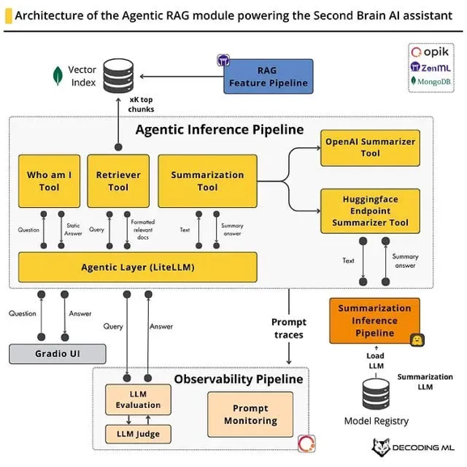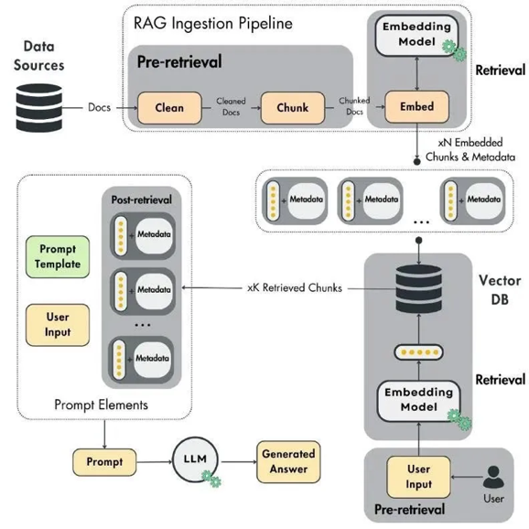
- EMR POC: read-only endpoint GET /emr/search?patient_id&fields&date_range&keywords, PHI scrubbing, consent flag, field whitelists, audit logs; EMR data is never bulk-indexed into the public KB.
- Architecture diagrams (Agentic RAG, Ingestion, Hand-sketch, Full sequence) were prepared as shared references; they set call order (UI→chat→routing/safety→prompt-builder→planner→(retriever/LTM/EMR)→synthesizer→logs) and clarified sidecar indexer boundaries.
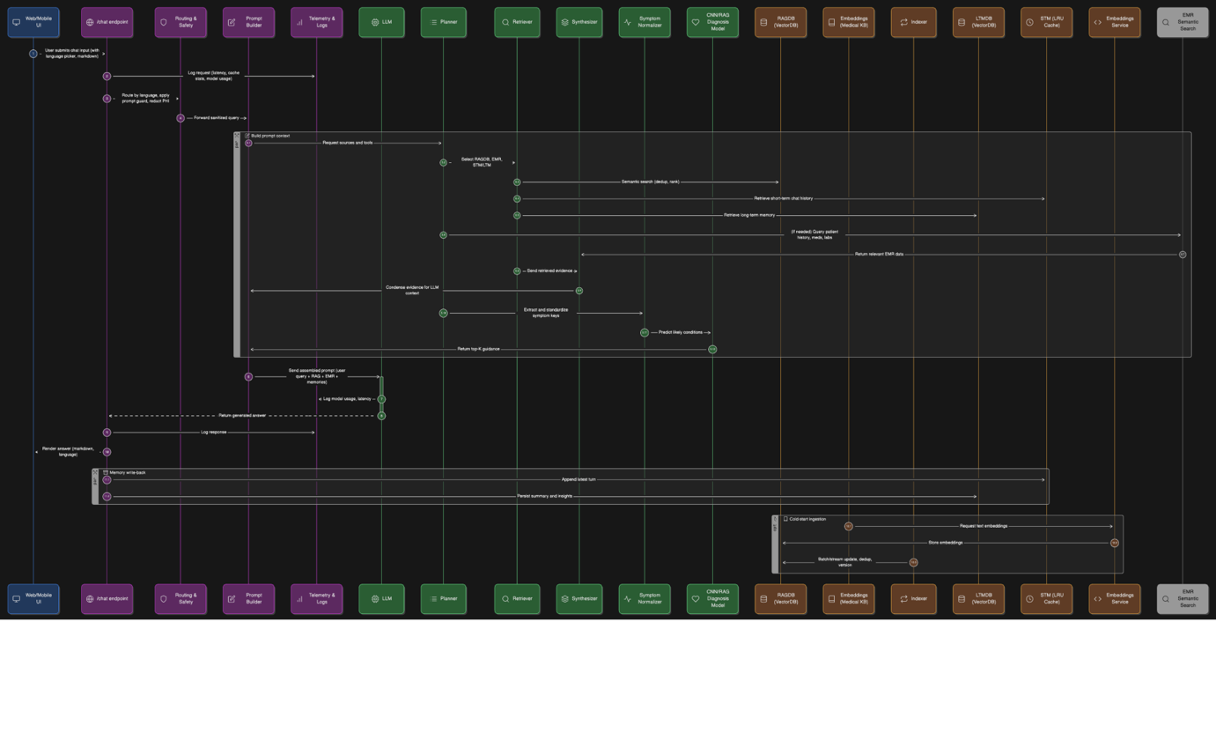
- Team structure & deliverables (A–D2) with Week-4 Prototype DoD were recorded: Docker/FastAPI + /chat, /retrieval/search, /indexer/ingest, /models/student, plus prompt traces/LLM-judge.

3) Quantitative progress
- Time logged: Week 3 = 18 h (12 h KD Dictionary, 6 h benchmarking).
Note: The Week-2 worklog covers Week 1 & Week 2 jointly (24 h total), so Week-2-only hours aren’t separable from the document.
- Benchmarks: MedAlpaca-7B 21.02% overall on 147,217 items; Pediatrics lowest (20.22%), Dental highest (24.37%).
Role Division Doc: https://hackmd.io/@ngFNmXW1RVOfNb7b3NYBJg/role

4) What we learned
- Harness rigor matters: Sub-random MCQ accuracy traced to format/decoding issues; we codified a strict schema (single-letter output), deterministic decoding, and few-shot format exemplars.
- Selective CoT (short, structured, citations-first) provides better factual grounding in distillation than long free-form rationales; we will continue with concise CoT.
- Student choice confirmed: Qwen3-8B (4-bit LoRA) is viable on local 24-GB hardware and will be our first fine-tune target; Qwen3-4B remains the fallback.

5) Risks & mitigations
Risk | Effect | Mitigation
GPU scarcity for MedGemma (teacher) | Slower KD throughput | Prefer Gemini-2.5 for remote CoT; short VastAI/Colab bursts for MedGemma.
MCQ format/parse errors | Artificially low scores | Hard schema (one-letter), deterministic decoding, subject few-shots.
Distilling hallucinated citations | Teaches bad habits | Citation regex checks + teacher selection + 5% clinician spot-checks.
Over-augmentation drift | Loss of clinical fidelity | Cap per-item augmentation; manual QA sampling.
EMR privacy | Compliance risk | Read-only, PHI scrubbing, consent flags, audit logs, field whitelist.

6) Concrete plan for the next fortnight (Weeks 4–5)

Week 4 — Phase-1 prototype online
- Endpoints live: /chat (RAG + STM/LTM + opt-in EMR with citations + safety disclaimer), /retrieval/search, /indexer/ingest, /models/student; prompt traces with LLM-judge pass/fail.
- Student SFT: LoRA on Qwen3-8B using balanced QAC + distilled CoT; publish MCQ accuracy vs. MedAlpaca baseline.
- KD batch: Generate 1k–2k teacher Q/A with concise CoT (focus: Pediatrics, Surgery, Medicine).
- Harness hardening: lock prompts/decoding/parse; subject-aware few-shots.

Week 5 — Reasoning & retrieval tuning
- GRPO pilot on three weakest subjects; log reward curves and accuracy lift.
- RAG tuning: chunk size & k-sweep, optional cross-encoder re-rank; report recall@k vs. latency.
- Routing & cost: enable round-robin keys; escalate uncertain answers to Gemini; collect latency/cost per route.

7) Deliverables & links index (from the two weekly worklogs)
- Fine-tuning Dictionary:
https://hackmd.io/@ngFNmXW1RVOfNb7b3NYBJg/instruction
- MedAlpaca-7B Benchmark CSV:
https://drive.google.com/file/d/1Uw0zW3gpW5FjONSdoRdAfzfgyEvUYyok/view?usp=sharing
- Benchmark Colab:
https://colab.research.google.com/drive/12PLhfgMa17FZtS6L8ChFh9WDZwBbfb7A?usp=sharing
- Architecture references (RAG, ingestion, sequence): captured in Week-2 worklog and used for peer sync and Phase-1 DoD.

Reflection
We now have a repeatable pipeline and evidence-based baseline. The next two weeks are about shipping the Phase-1 service and converting KD/GRPO theory into measurable accuracy gains while keeping safety and EMR privacy non-negotiable.

